



LAB MANUAL
DBMS

Disclaimer: The content is curated from online/offline resources and used for educational purpose only
Finding GCD Using Euclidean Algorithm
Objective:
To implement the Euclidean algorithm in Python to find the Greatest Common Divisor (GCD) of two integers.

Problem Statement:
Write a Python function to compute the Greatest Common Divisor (GCD) of two numbers using the Euclidean algorithm.

Equipment Required:
- Computer with Python 3.x installed
- Jupyter Notebook or any Python IDE

Prerequisites:
- Basic Python programming knowledge
- Understanding of loops and conditionals
- Basic number theory concept: GCD

Procedure:
Step 1: Understand the Euclidean Algorithm

The Euclidean algorithm finds the GCD of two numbers based on the principle:
GCD(a, b) = GCD(b, a % b)
Where % is the modulo operator. The algorithm repeats this process until b becomes 0, and then a is the GCD.

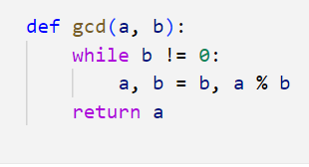

Step 2: Check the function

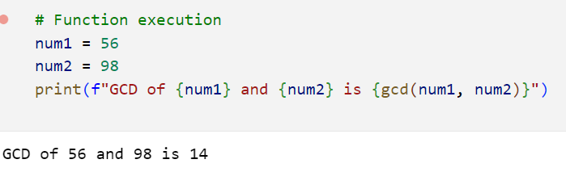

Step 3: Explanation
- The function takes two integers, a and b.
- It uses a while loop that runs until b becomes zero.
- In each iteration, we replace a with b, and b with a % b.
- When b becomes zero, a holds the GCD.
- The function then returns a.

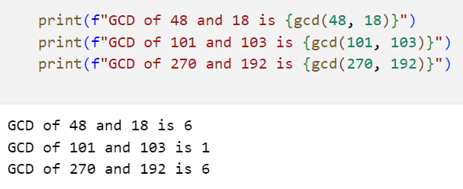

Conclusion
The Euclidean algorithm efficiently computes the Greatest Common Divisor (GCD) of two numbers using repeated modulo operations. It is one of the oldest and fastest methods for finding the GCD and forms the basis of many number theory applications.

